ARM Template to deploy all the Cosmos DBs

Step 1: Go to Azure portal <https://portal.azure.com>. Click on create a new resource and select template deployment in the marketplace.

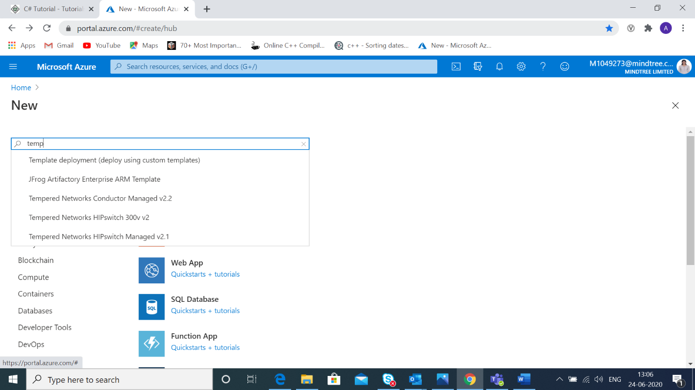 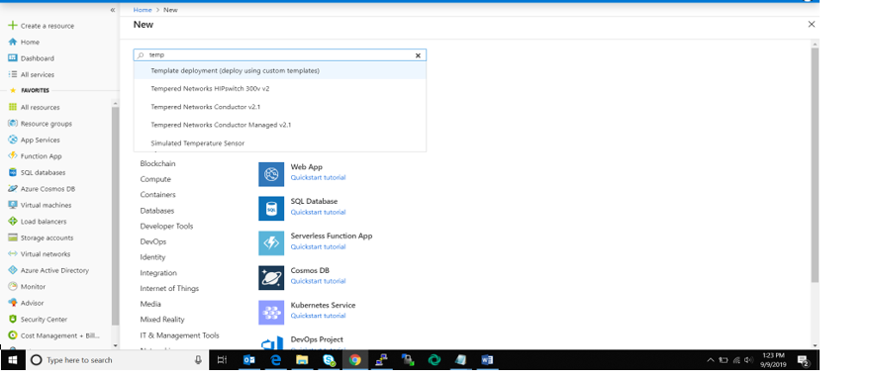

Step 2: Click on build your own template.

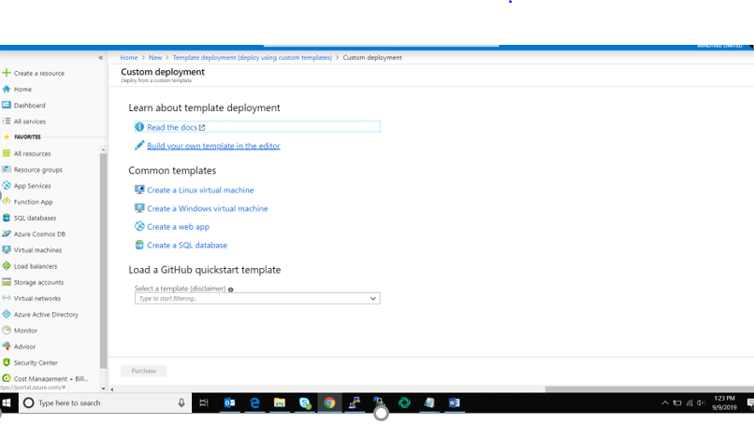

Step 3: Write the ARM template for creating a Cosmos DBs and filling in the required configuration then click on purchase. We will get a message that the deployment is under process.

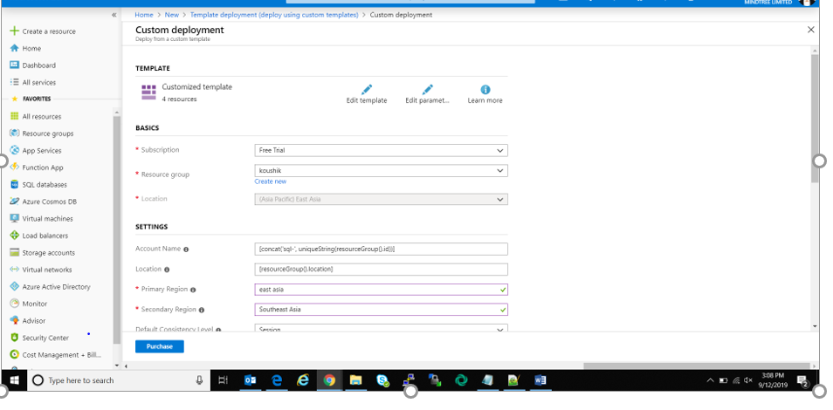

After the deployment is completed we can access the cosmos DB account as shown.

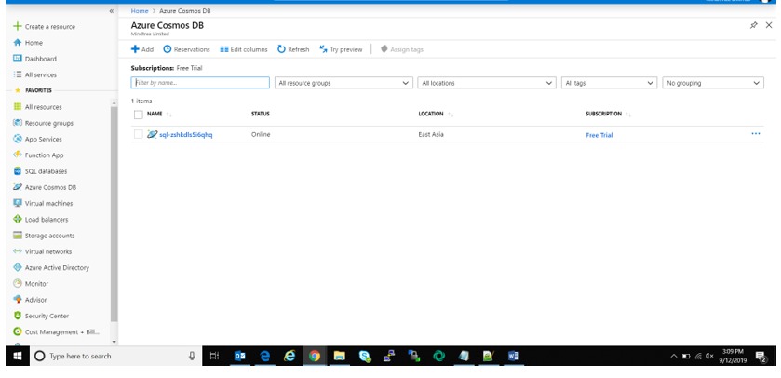

View the Cosmos DB account by clicking on the respected DB.

